VISVESVARAYA TECHNOLOGICAL UNIVERSITY
"Jnana Sangama", Belagavi-590 018
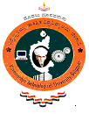

A Project Work on

“ANDROID BASED COURSE DELIVERY AND EVALUATION SYSTEM”

A Dissertation work submitted in partial fulfillment of the requirement
for the award of the degree

Bachelor of Engineering
In
Information Science & Engineering

Submitted by
Mr. Bidish Basu 1AY12IS021
Mr. Nandan A 1AY12IS051
Mr. Vignesh N K 1AY12IS096
Mr. Y G Sriram 1AY12IS100

Under the guidance of
Prof. C. K. Marigowda
Associate Professor & HOD

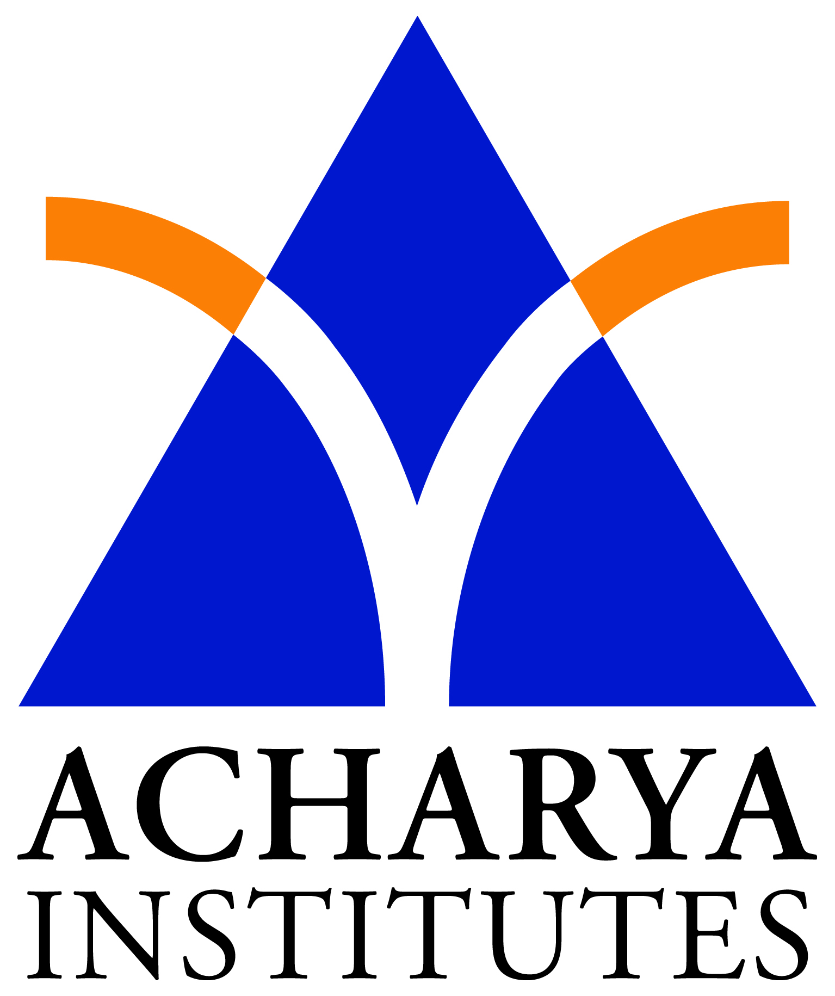

DEPARTMENT OF INFORMATION SCIENCE & ENGINEERING
ACHARYA INSTITUTE OF TECHNOLOGY
(AFFILIATED TO VISVESVARAYA TECHNOLOGICAL UNIVERSITY, BELAGAVI.APPROVED BY AICTE, NEW DELHI)
Acharya Dr. Sarvepalli Radhakrishnan Road, Soldevanahalli, Bengaluru-560107

2015-16

